**C++ File Pointers**

Every file maintains two pointers called get_pointer (in input mode file) and put_pointer (in output mode file) which tells the current position in the file where reading or writing will take place. (A file pointer in this context is not like a C++ pointer but it works like a book-mark in a book.). These pointers help attain random access in file. That means moving directly to any location in the file instead of moving through it sequentially.

There may be situations where random access in the best choice. For example, if you have to modify a value in record no 21, then using random access techniques, you can place the file pointer at the beginning of record 21 and then straight-way process the record. If sequential access is used, then you'll have to unnecessarily go through first twenty records in order to reach at record 21.

**The seekg(), seekp(), tellg() and tellp() Functions**

In C++, random access is achieved by manipulating seekg(), seekp(), tellg() and tellp() functions. The seekg() and tellg() functions allow you to set and examine the get_pointer, and the seekp() and tellp() functions perform these operations on the put_pointer.

The seekg() and tellg() functions are for input streams (ifstream) and seekp() and tellp() functions are for output streams (ofstream). However, if you use them with an fstream object then tellg() and tellp() return the same value. Also seekg() and seekp() work the same way in an fstream object. The most common forms of these functions are :

|  |  |  |
| --- | --- | --- |
| seekg() | istream & seekg(long); istream & seekg(long, seek_dir); | Form 1 Form 2 |
| seekp() | ofstream & seekp(long); ofstream & seekp(long, seek_dir); | Form 1 Form 2 |
| tellg() | long tellg() |  |
| tellp() | long tellp() |  |

The working of seekg() & seekp() and tellg() & tellp() is just the same except that seekg() and tellg() work for ifstream objects and seekp() and tellp() work for ofstream objects. In the above table, seek_dir takes the definition enum seek_dir { beg, cur, end};.

The seekg() or seekp(), when used according to Form 1, then it moves the get_pointer or put_pointer to an absolute position. Here is an example:

ifstream fin;

ofstream fout;

: // file opening routine

fin.seekg(30); // will move the get_pointer (in ifstream) to byte number 30 in the file

fout.seekp(20); // will move the put_pointer (in ofstream) to byte number 20 in the file

When seekg() or seekp() function is used according to Form 2, then it moves the get_pointer or put_pointer to a position relative to the current position, following the definition of seek_dir. Since, seek_dir is an enumeration defined in the header file iostream.h, that has the following values:

ios::beg, // refers to the beginning of the file

ios::cur, // refers to the current position in the file

ios::end} // refers to the end of the file

Here is an example.

fin.seekg(30, ios::beg); // go to byte no. 30 from beginning of file linked with fin

fin.seekg(-2, ios::cur); // back up 2 bytes from the current position of get pointer

fin.seekg(0, ios::end); // go to the end of the file

fin.seekg(-4, ios::end); // backup 4 bytes from the end of the file

The functions tellg() and tellp() return the position, in terms of byte number, of put_pointer and get_pointer respectively, in an output file and input file.

Seekg(): Member function of ifstream. Used to moves the get pointer to the specific position.

Seekp(): Member function of ofstream. Used to moves the put pointer to the specific position.

tellg(): Member function of ifstream. Gives the current position of the get pointer.

tellp(): Member function of ofstream. Gives the current position of the put pointer.

Example program:

#include<iostream>

#include<fstream>

using namespace std;

int main()

{

int pos;

char str[80];

fstream ofile;

ofile.open("my_file.txt", ios::in|ios::out);

ofile<<"This is a sample file which illustrates the file pointer concept from file handling in c++";

cout<<"Current Position of put pointer:";

cout<<ofile.tellp();

cout<<"\n Enter the position to move from beginning:";

cin>>pos;

ofile.seekg(pos,ios::beg);

cout<<"\n The position of the getpointer is:";

cout<<ofile.tellg();

ofile.getline(str,82);

cout<<endl<<str;

}

Output:

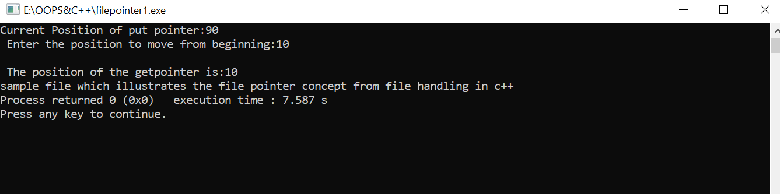

Data in my_file.txt is

